**DevOps: An Overview, It’s Advantages**

**DevOps** is a cultural and technical movement that aims to unify software development (Dev) and IT operations (Ops) to enable shorter development cycles, increased deployment frequency, and more dependable releases, all in close alignment with business objectives. By bridging the gap between traditionally siloed teams, DevOps builds a collaborative approach throughout the software development lifecycle, from planning and coding to testing, deployment, and maintenance

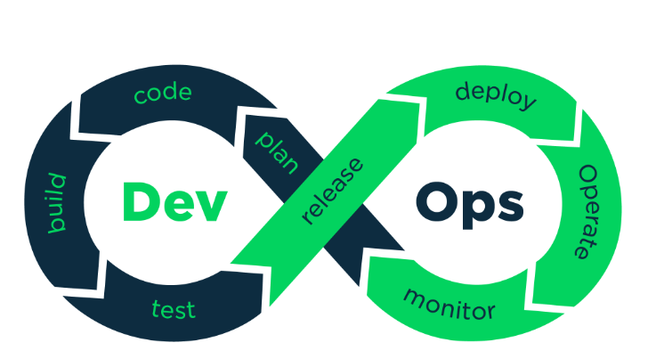

**Key Principles of DevOps**

* **Collaboration:** Encourages open communication between development and operations teams, breaking down silos for shared responsibility.
* **Automation:** Implements continuous integration/continuous deployment (CI/CD) pipelines and automated testing frameworks to streamline processes.
* **Continuous Feedback:** Focuses on real-time monitoring and feedback to catch issues early and improve future releases.
* **Culture of Improvement:** Instills an ethos of continuous learning, experimentation, and improvement through frequent iteration.
* 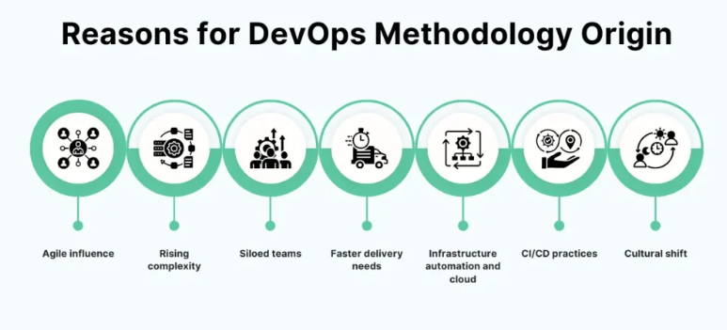**Security Integration:** Embeds security practices (sometimes called DevSecOps) throughout the software lifecycle, not just at the end.

**Advantages of DevOps**

**1. Faster Time to Market**

DevOps practices, such as automation and seamless collaboration, enable organizations to release new features, updates, and bug fixes more frequently. This speed gives companies a vital competitive advantage, allowing them to respond quickly to market demands and customer feedback

**2. Improved Product Quality**

Continuous integration, automated testing, and regular monitoring under DevOps ensure that bugs are caught and resolved early. This lets teams deliver higher-quality features and reduces the risk and cost of defects making it to production.

**3. Enhanced Collaboration and Transparency**

DevOps fosters a culture where teams share responsibilities and maintain open lines of communication. Developers, QA, and Ops personnel work together with common goals, reducing inefficiencies, miscommunication, and handoff-related delays. This transparency boosts morale, trust, and overall productivity.

**4. Higher Reliability**

With practices like continuous delivery and automated testing, organizations ensure that updates and infrastructure changes are dependable. Monitoring and logging further help teams stay informed and quickly address system issues, thereby reducing downtime and improving service stability.

**5. Streamlined Resource Management**

Replacing manual processes with automation frees up resources, allowing staff to focus on higher-value work. DevOps also helps organizations make the most of their infrastructure, reducing redundant tasks and unnecessary overhead.

**6. Cost Savings and Efficiency**

Efficient resource use, reduction in errors and bottlenecks, and optimized workflows all translate into lower costs. With DevOps, there is less rework, downtime, and wasted effort, leading to improved profitability.

**7. Flexibility and Scalability**

DevOps enables organizations to scale systems and processes as demand changes. Using infrastructure as code and other DevOps practices, scaling up or down becomes faster, safer, and more efficient.

**8. Enhanced Security and Compliance**

By integrating security practices into the development process, DevOps ensures compliance is maintained from the outset, minimizing the risk of vulnerabilities and making the whole system more robust.

**9. Increased Customer Satisfaction**

Frequent, high-quality releases, combined with quick responses to user feedback, help to deliver what customers actually want. Continuous improvement ensures that customer satisfaction is always prioritized.

**Conclusion**

DevOps is an essential methodology for modern IT organizations aiming for speed, reliability, and business agility. The adoption of DevOps brings together people, processes, and technology, breaking down barriers and enabling a continuous cycle of improvement. Its numerous benefits not only make software development and deployment more efficient but also drive customer satisfaction and business growth